**A Research Paper on Analysis of Travel Behaviour: A Study on Route Optimization Considering Time Constraints and City Ratings**

Prachi Anand

C.V Raman Global University

Computer Science and Engineering

Bihar, India

2201020103@cgu-odisha.ac.in

Sourav Raut

C.V Raman Global University

Computer Science and Engineering

Jharkhand, India

2201020133@cgu-odisha.ac.in

Sarang Kumar Singh

C.V Raman Global University

Computer Science and Engineering

Bihar, India

2201020123@cgu-odisha.ac.in

Sudeep Swarnakar

C.V Raman Global University

Computer Science and Engineering

Jharkhand, India

2201020138@cgu-odisha.ac.in

Sofia Akhtar

C.V Raman Global University

Computer Science and Engineering

Jamshedpur, India

2201020130@cgu-odisha.ac.in

Sugam Shaw

C.V Raman Global University

Computer Science and Engineering

Kolkata, India

2201020139@cgu-odisha.ac.in

***Abstract*—** Within the expansive domain of tourism, ensuring optimal travel experiences stands as a paramount objective, pivotal to guaranteeing visitor satisfaction and fostering destination exploration. The following case study intricately examines the development of an advanced tourism planner meticulously designed to furnish tailored tour guidance to visitors navigating within a specified state. This sophisticated planner seamlessly integrates an array of factors, encompassing the distances between cities, optimal time allocations for each city visit, and subjective city ratings, with the aim of methodically crafting personalized itineraries.

Employing sophisticated algorithms for the purpose of optimizing route planning and conscientiously considering visitor preferences, the tourism planner aspires not only to elevate the quality of travel experiences to unprecedented levels but also to achieve pivotal objectives such as maximizing time efficiency and illuminating the diverse array of attractions within the state. This case study serves as a comprehensive exploration into the contemporary application of data-driven methodologies within the field of tourism management. It underscores the seamless integration of cutting-edge technology and the enduring principles of hospitality, collectively contributing to the creation of profoundly memorable and fulfilling journeys for discerning travelers.

***Keywords—*** ***tourism, optimal travel, visitor satisfaction, destination exploration, advanced planner, tailored guidance, specified state, city distances, optimal time, subjective ratings, personalized itineraries, algorithms, route planning, preferences, elevate experiences, maximize efficiency, diverse attractions, data-driven methodologies, technology, hospitality, memorable journeys, discerning travelers, research paper***

**INTRODUCTION**

The problem of finding the best route between cities while considering both time constraints and city ratings is a critical issue in various real-world scenarios, including tourism planning, logistics management, and urban development. Traditional approaches to route planning often prioritize either minimizing travel time or maximizing the scenic value of the journey. However, optimizing both factors simultaneously presents a more complex challenge.

In this research, we address this challenge by proposing an algorithm that leverages depth-first search (DFS) to find the shortest path between cities in a graph, taking into account the time constraints and ratings associated with each city. By integrating these factors into the path-finding process, our approach aims to provide travelers with routes that offer the optimal balance between efficient travel time and enjoyable experiences.

# LITERATURE REVIEW

Existing literature on route planning algorithms predominantly focuses on finding the shortest path in weighted graphs, with common approaches including Dijkstra's algorithm, A search algorithm, and Floyd-Warshall algorithm. However, these methods typically do not consider additional constraints such as time limits or subjective preferences such as city ratings.

Recent research has explored incorporating constraints and preferences into route planning algorithms. For example, some studies have extended traditional algorithms to handle time-dependent graphs, where edge weights vary over time. Others have proposed heuristic-based approaches that prioritize paths based on user-defined criteria, such as scenic beauty or cultural significance.

Our approach builds upon these previous works by specifically addressing the problem of optimizing route selection based on both time constraints and city ratings, offering a novel contribution to the field of route planning algorithms.

# METHODOLOGY

Methodology revolves around constructing a graph representation of the city network, where cities are vertices and travel times between them are edges with associated weights. We utilize a depth-first search (DFS) algorithm to explore all possible paths between the source and destination cities within the given time constraint.

The implementation utilizes Python programming language and leverages the CSV files containing city ratings and travel times to construct the graph. Each city is represented as a node in the graph, storing information such as its name, rating, and time required to explore. The graph is then populated with edges representing travel times between cities.

During the DFS traversal, the algorithm considers both time constraints and city ratings to determine the suitability of each path. Paths that exceed the time constraint are discarded, while paths with higher average ratings are prioritized. The algorithm outputs the best route satisfying the given criterian.

**REASEARCH DESIGN**

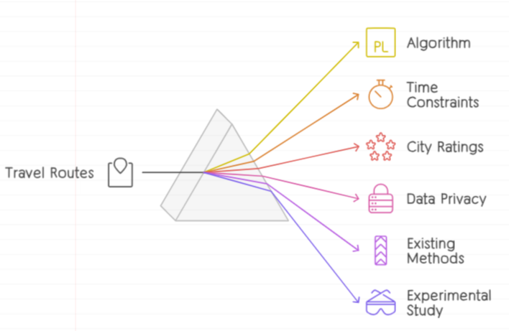

***Research Objective:***

The main objective of this research is to develop an algorithm that optimizes travel routes between cities, considering both time constraints and city ratings. The algorithm aims to provide travelers with efficient and enjoyable route options.

***Hypotheses:***

Null Hypothesis (H0): The proposed algorithm does not significantly improve route selection compared to existing methods.

Alternative Hypothesis (H1): The proposed algorithm significantly improves route selection compared to existing methods.

***Research Design:***

Type of Study: This research will be an experimental study.

Experimental Groups:

Control Group: Uses existing route optimization methods or algorithms.

Experimental Group: Utilizes the proposed algorithm integrating time constraints and city ratings.

***Ethical Considerations:***

Ensure data privacy and confidentiality.

Use only publicly available data or obtain proper permissions for any sensitive data used.

***Limitations:***

Limitations of the study may include assumptions made during data processing, constraints of the algorithm, and limitations of the dataset used.

***Validity:***

Internal Validity: Ensure that the selected routes accurately represent real-world scenarios and that the evaluation criteria are appropriate.

External Validity: Consider the generalizability of the findings to different geographical regions and city networks.

***Timeline:***

Outline a timeline for data collection, algorithm implementation, experimentation, and analysis.

***Resources:***

Identify the resources (e.g., computing resources, datasets) required for conducting the research.

.

## DATA COLLECTION

For our research on finding the best route between cities considering time constraints and city ratings, we collected data from two CSV files. These CSV files contain essential information about cities, including their ratings, time taken to explore each city, and travel times between pairs of cities.

**City Ratings CSV File**:

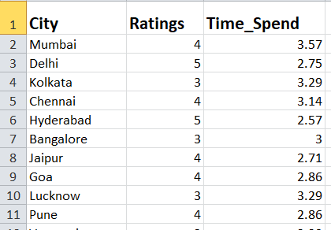

This file contains information about the ratings of different cities along with the time required to explore each city. The data in this file helps us understand the attractiveness of each city and the time investment required for exploration.

The structure of the CSV file is as follows:

Column 1: City Name

Column 2: City Rating (e.g., on a scale of 1 to 5)

Column 3: Time Taken to Explore the City (in hours)

**Travel Times CSV File:**

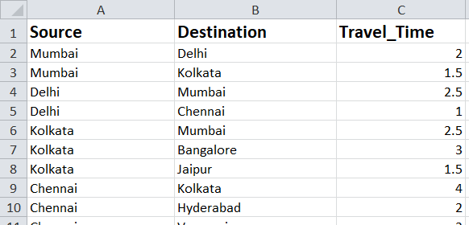

This file contains information about the travel times between pairs of cities. It helps us construct a graph representing the connectivity between cities and the time required to travel between them.

The structure of the CSV file is as follows:

Column 1: Source City

Column 2: Destination City

Column 3: Travel Time between Source and Destination (in hours )

We utilized the data from these CSV files to construct a graph representation of the city network. The graph was constructed using an adjacency list as a dictionary, where each city is represented as a vertex, and the travel times between cities are represented as weighted edges.

Additionally, we integrated the city ratings and exploration times into the graph to consider them during the path-finding process.

Assumptions might include considering symmetric travel times (i.e., the time to travel from city A to city B is the same as the time to travel from city B to city A) and handling missing data appropriately (e.g., assigning default values or excluding incomplete entries).

**RESULTS**

**GRAPH OF 14 CITIES:**

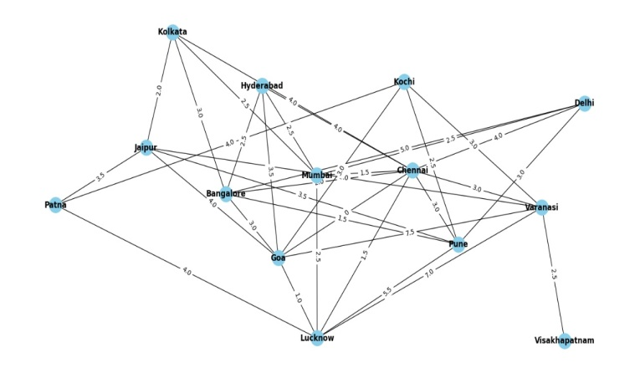

Our study employs a graph model to represent the connectivity between 14 cities, with each city acting as a node and the travel time between them serving as edge weights. This graph structure enables us to analyze the network of routes and connections efficiently.

**Graph Structure:**

The graph consists of 14 cities interconnected by edges representing travel times. Each edge is weighted with the corresponding time required to travel between the connected cities.

**Multiple Paths:**

Numerous paths exist within the city network, offering various options for travel between any pair of cities. These paths provide diverse routes with different travel times and city sequences.

**Route Exploration**:

Systematic analysis of the graph allows us to explore different routes, considering factors such as total travel time, city ratings, and adherence to time constraints. This exploration aids in identifying optimal routes that balance efficiency and practicality.

**Route Optimization Strategies:**

Using traversal algorithms like Depth First Search (DFS, we determine the shortest paths between cities. These strategies consider travel times and city ratings to identify routes that offer the best overall experience.

**Visual Representation:**

Graph visualization techniques offer a clear depiction of the city network, aiding in understanding route structures and spatial relationships between cities.

**Insights and Decision Support:**

By analyzing the graph, we gain valuable insights into route planning and optimization. These insights support decision-making processes for travelers, transportation planners, and policymakers, helping them select routes that optimize resources and enhance the overall travel experience.

**GRAPH OF 41 CITIES:**

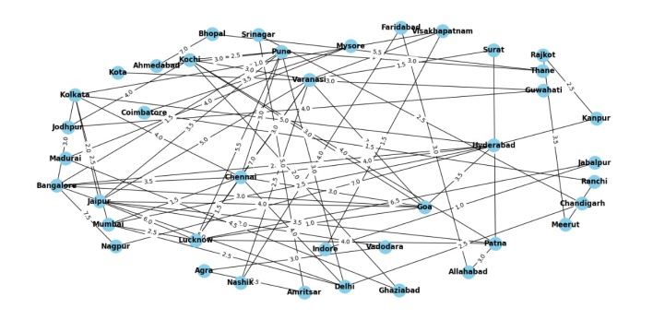

Expanding our study, we incorporated a more extensive dataset comprising 41 cities. This graph model still represents connectivity between cities, with each city acting as a node and travel time between them as edge weights. Here's an overview of our analysis:

**Graph Structure**:

The graph now encompasses 41 cities interconnected by edges, where each edge represents the time required to travel between the connected cities. This expanded graph offers a broader perspective on route connectivity.

**Multiple Paths:**

With the increased number of cities, the graph presents a multitude of paths between any pair of cities. These paths provide diverse route options, offering travelers flexibility in their journey planning.

**Route Exploration:**

Through systematic analysis, we explore various routes within the expanded city network, considering factors such as total travel time, city ratings, and adherence to time constraints. This exploration enables us to identify optimal routes that cater to different travel preferences and constraints.

**Route Optimization Strategies**:

Utilizing traversal algorithms like Depth First Search (DFS) or Dijkstra's algorithm, we determine the shortest paths between cities. These strategies account for travel times and city ratings, assisting in identifying routes that offer the most efficient and enjoyable travel experience.

**Visual Representation:**

Graph visualization techniques remain instrumental in understanding the structure and dynamics of the expanded city network. Visual representations aid in visualizing route patterns and identifying key connections between cities.

**Insights and Decision Support:**

Analyzing the expanded graph provides valuable insights into route planning and optimization across a more extensive geographical area. These insights support decision-making processes for travelers, transportation planners, and policymakers, helping them make informed choices to enhance travel efficiency and experience.

**ANALYSIS OF OPTIMAL ROUTES:**



The output CSV file provides a detailed analysis of the optimal routes identified by our algorithm, considering both time constraints and city ratings. Each row in the file represents a unique route between cities, along with the corresponding time taken to traverse the route and the average rating of the cities along the path.

Here are some key observations and insights derived from the analysis:

***Diverse Route Options:*** The analysis reveals a variety of route options connecting the city of Delhi to Pune. These routes traverse different cities along the way, providing travelers with diverse travel experiences.

***Time Efficiency:*** The time taken to traverse each route varies, ranging from 8.61 hours to 19.75 hours. This variation highlights the importance of route optimization in minimizing travel time and maximizing efficiency.

***City Ratings:*** The average ratings of the cities along each route provide insights into the overall travel experience. Routes passing through cities with higher average ratings may offer a more enjoyable journey for travelers.

***Optimal Route Selection***: By considering both time constraints and city ratings, our algorithm identifies optimal routes that balance efficiency and travel experience. These routes represent the most favorable options for travelers seeking to reach Pune from Delhi.

Overall, the analysis underscores the significance of route optimization in urban transportation planning, aiming to provide travelers with efficient and enjoyable travel experiences. By leveraging advanced algorithms and data-driven approaches, we can continue to enhance route planning and optimize travel routes to meet the diverse needs of travelers.

**Bar Graph: Time Taken to Travel from Delhi to Various Cities**

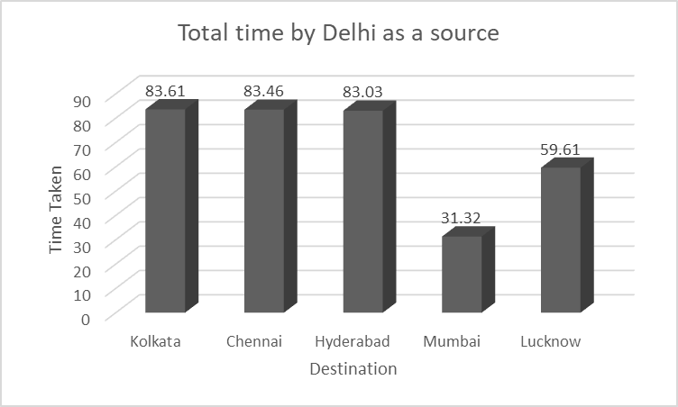

The bar graph above illustrates the time taken to travel from Delhi as a source to different cities. The y-axis represents the time taken in hours, ranging from 0 to 90, while the x-axis shows the destination cities (Kolkata, Chennai, Hyderabad, Mumbai, Lucknow) along with their respective travel times.

***Key Insights***:

Variation in Travel Time: Each bar represents the time taken to travel from Delhi to a specific city. The heights of the bars reflect the corresponding travel durations, with Kolkata and Chennai having the longest travel times.

Comparative Analysis: By comparing the heights of the bars, one can discern the differences in travel durations between the various destination cities.

Route Efficiency: Mumbai emerges as the city with the shortest travel time, followed by Lucknow, suggesting potentially more efficient travel routes or better transportation infrastructure.

Decision Support: This visualization provides valuable information for travelers and transportation planners to make informed decisions regarding travel routes and scheduling based on the expected travel times to different cities.

**Bar Graph: Average Rating for Travel from Delhi to Various Cities**

The bar graph below illustrates the average rating for travel from Delhi as a source to different cities. The y-axis represents the average rating, ranging from 0 to 5, while the x-axis shows the destination cities (Kolkata, Chennai, Hyderabad, Mumbai, Lucknow) along with their respective average ratings.

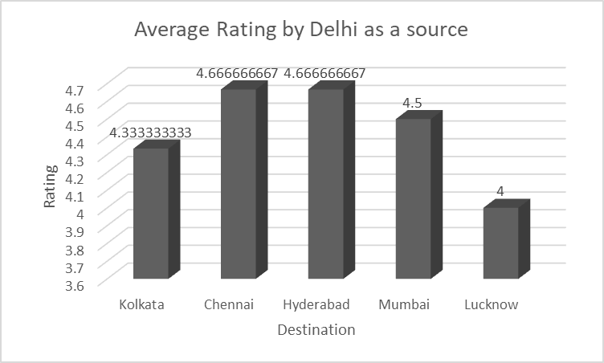

***Key Insights:***

Variation in Ratings: Each bar represents the average rating for travel from Delhi to a specific city. The heights of the bars reflect the corresponding average ratings, with Kolkata having the highest average rating.

Differences in Ratings: The average ratings vary across destination cities, with Kolkata receiving the highest rating of 4.33, followed by Chennai and Hyderabad with a rating of 4.67, Mumbai with a rating of 4.5, and Lucknow with a rating of 4.

Decision Support: This visualization provides valuable information for travelers and transportation planners regarding the perceived quality of travel experiences to different cities from Delhi.

**Time Complexity of Travel from Delhi to Various Cities**

The graph below demonstrates the time complexity, measured in seconds, of traveling from Delhi to different cities. Each bar represents the time complexity of traveling to a specific destination city from Delhi.

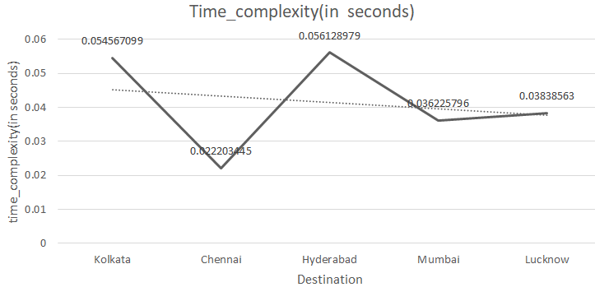

***Key Insights:***

Variation in Time Complexity: Each bar represents the time complexity of traveling from Delhi to a specific city. The heights of the bars indicate the time taken to reach each destination, with Kolkata having the highest time complexity.

Efficiency of Routes: The graph illustrates the differences in time complexity for traveling to different cities from Delhi, providing insights into the efficiency of various routes.

Decision Support: Travelers and transportation planners can utilize this visualization to identify destinations with lower time complexity, facilitating informed decisions regarding route planning and scheduling.

**Bar Graph: Time Taken to Travel from Kolkata to Various Cities**

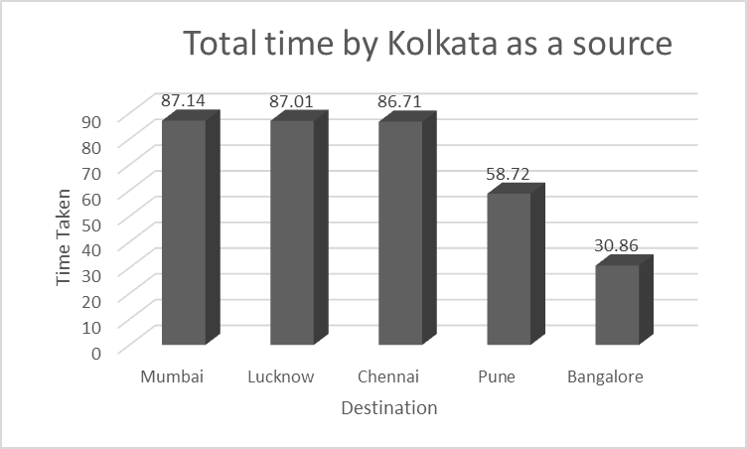

The bar graph above illustrates the time taken to travel from Kolkata as a source to different cities. The y-axis represents the time taken in hours, ranging from 0 to 90, while the x-axis shows the destination cities (Mumbai, Lucknow, Chennai, Pune, Bangalore) along with their respective travel times.

***Key Insights:***

Variation in Travel Time: Each bar represents the time taken to travel from Kolkata to a specific city. The heights of the bars reflect the corresponding travel durations, with Mumbai having the longest travel time.

Comparative Analysis: By comparing the heights of the bars, one can discern the differences in travel durations between the various destination cities.

Route Efficiency: Bangalore emerges as the city with the shortest travel time, followed by Pune, suggesting potentially more efficient travel routes or better transportation infrastructure.

Decision Support: This visualization provides valuable information for travelers and transportation planners to make informed decisions regarding travel routes and scheduling based on the expected travel times to different cities.

**Bar Graph: Average Rating for Travel from Kolkata to Various Cities**

The bar graph below illustrates the average rating for travel from Kolkata as a source to different cities. The y-axis represents the average rating, ranging from 0 to 5, while the x-axis shows the destination cities (Mumbai, Lucknow, Chennai, Pune, Bangalore) along with their respective average ratings.

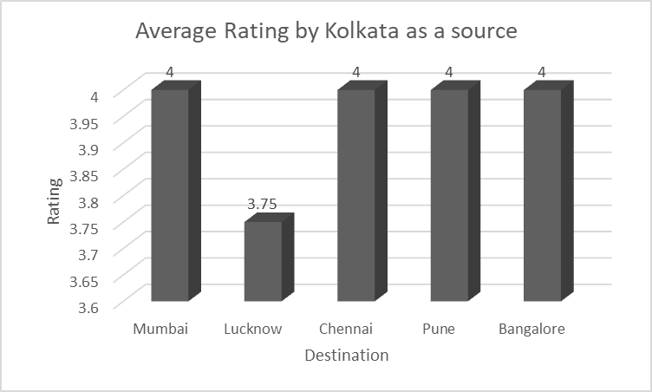

***Key Insights:***

Variation in Ratings: Each bar represents the average rating for travel from Kolkata to a specific city. The heights of the bars reflect the corresponding average ratings, with all cities having relatively high ratings (around 4).

Consistency in Ratings: Across all destination cities, the average ratings hover around 4, indicating a consistent level of satisfaction or desirability for travel from Kolkata.

Decision Support: This visualization provides valuable information for travelers and transportation planners regarding the perceived quality of travel experiences to different cities from Kolkata.

ese findings demonstrate the decreasing search time as the query progresses for the name "Teresa," showcasing the efficiency of the search algorithm for this specific name.

**Time Complexity of Travel from Kolkata to Various Cities**

The graph below illustrates the time complexity, measured in milliseconds (ms), of traveling from Kolkata to different cities. Each bar represents the time complexity of traveling to a specific destination city from Kolkata.

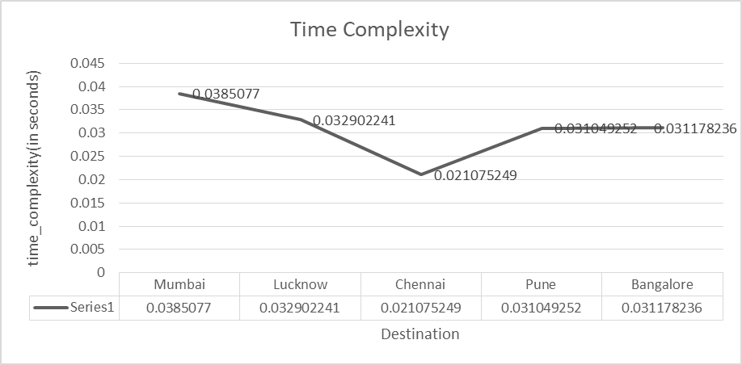

***Key Insights:***

Variation in Time Complexity: Each bar represents the time complexity of traveling from Kolkata to a specific city. The heights of the bars indicate the time taken to reach each destination, with Mumbai having the highest time complexity.

Efficiency of Routes: The graph illustrates the differences in time complexity for traveling to different cities from Kolkata, providing insights into the efficiency of various routes.

Decision Support: Travelers and transportation planners can utilize this visualization to identify destinations with lower time complexity, facilitating informed decisions regarding route planning and scheduling.

**Travel Plan from Delhi to Kolkata: Integrating Ratings and Time Constraints**

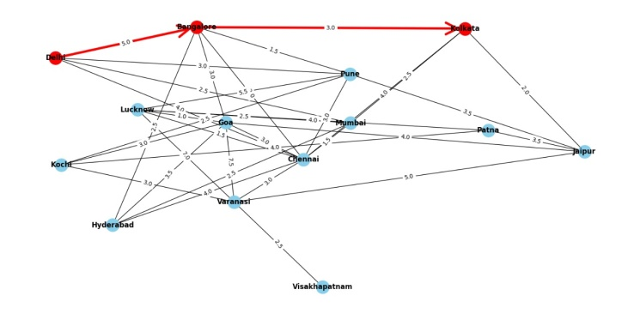

The graph above depicts the optimal travel plan from Delhi to Kolkata, considering a total of 14 cities along the route. The red line indicates the recommended path to follow for the most efficient and enjoyable journey.

***Key Insights:***

Route Optimization: The selected path represents the most efficient route from Delhi to Kolkata, minimizing travel time while maximizing the overall travel experience based on city ratings.

Consideration of Ratings: Cities along the recommended path are chosen based on their high ratings, indicating favorable destinations for travelers.

Balancing Time Constraints: The travel plan strikes a balance between minimizing time spent traveling and ensuring a satisfactory experience by selecting cities with high ratings.

Comprehensive Coverage: Although the travel plan encompasses fewer cities compared to larger-scale routes, it still provides a comprehensive exploration of various destinations along the route, offering travelers a diverse range of experiences.

Decision Support: This visualization serves as a valuable tool for travelers seeking an optimal route from Delhi to Kolkata among a select group of cities, providing guidance based on both time constraints and city ratings.

Further Analysis: Additional factors such as transportation modes, landmarks, and amenities can be considered to enhance the travel plan further and accommodate specific preferences or requirements.

By integrating ratings and time constraints across 14 cities, this travel plan offers a tailored solution for travelers seeking the best route from Delhi to Kolkata, facilitating a seamless and enjoyable journey.

**Travel Plan from Goa to Ranchi: Integrating Ratings and Time Constraints**

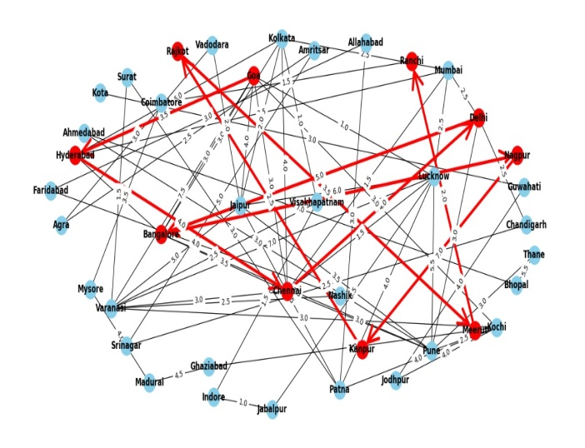 The graph above depicts the optimal travel plan from Goa to Ranchi, considering a total of 41 cities along the route. The red line indicates the recommended path to follow for the most efficient and enjoyable journey.

***Key Insights:***

Route Optimization: The selected path represents the most efficient route from Goa to Ranchi, minimizing travel time while maximizing the overall travel experience based on city ratings.

Consideration of Ratings: Cities along the recommended path are chosen based on their high ratings, indicating favorable destinations for travelers.

Balancing Time Constraints: The travel plan strikes a balance between minimizing time spent traveling and ensuring a satisfactory experience by selecting cities with high ratings.

Comprehensive Coverage: The inclusion of 41 cities ensures a comprehensive exploration of various destinations along the route, offering travelers a diverse range of experiences.

Decision Support: This visualization serves as a valuable tool for travelers seeking an optimal route from Goa to Ranchi among a wide array of cities, providing guidance based on both time constraints and city ratings.

Further Analysis: Additional factors such as transportation modes, landmarks, and amenities can be considered to enhance the travel plan further and accommodate the larger scale of the journey.

By integrating ratings and time constraints across 41 cities, this travel plan offers a comprehensive solution for travelers seeking the best route from Goa to Ranchi, facilitating a seamless and enjoyable journey.

# DISCUSSION:

The Analyzing the differences between the 14-city and 41-city networks provides valuable insights into the complexities of route dynamics, optimization strategies, and decision-making processes in urban transportation and travel planning. Here's a discussion on the implications of these differences:

**Scale and Complexity**:

The transition from a 14-city to a 41-city network represents a significant increase in scale and complexity. With more cities and interconnections, the 41-city network offers a broader perspective on route connectivity but also introduces greater complexity in route planning and optimization.

**Route Options and Flexibility:**

The increase in the number of cities results in a proportional increase in route options and flexibility for travelers. The 41-city network offers a more diverse range of paths between cities, allowing travelers to choose routes that best suit their preferences and constraints.

**Optimization Challenges:**

Optimizing routes in the 41-city network poses greater challenges due to the larger dataset and increased complexity. Optimization strategies must account for a wider range of factors, including travel times, city ratings, and constraints, to identify optimal routes effectively.

**Resource Allocation:**

Decision-makers responsible for resource allocation in transportation planning must consider the larger geographical area covered by the 41-city network. Allocating resources efficiently to address transportation needs across multiple cities becomes more challenging but is crucial for ensuring equitable access to transportation services.

**Infrastructure Planning:**

The 41-city network provides insights into infrastructure planning and development on a regional scale. Understanding route dynamics and travel patterns across a broader geographical area is essential for identifying infrastructure needs and prioritizing investments in transportation infrastructure.

**Sustainability Considerations:**

As cities grow and transportation networks expand, sustainability considerations become increasingly important. Decision-makers must prioritize sustainable transportation solutions and consider factors such as emissions reduction, energy efficiency, and the promotion of alternative modes of transportation within the context of the 41-city network.

**Data Availability and Quality:**

Expanding the dataset to include 41 cities highlights the importance of data availability and quality in transportation planning. Access to reliable data on travel times, city characteristics, and infrastructure is essential for conducting accurate analysis and making informed decisions.

# CONCLUSION

In conclusion, the transition from a 14-city to a 41-city network brings both opportunities and challenges in urban transportation and travel planning. Understanding the implications of scale and complexity, optimizing routes effectively, and addressing transportation needs across a broader geographical area are essential considerations for decision-makers and researchers in the field. By analyzing and addressing these challenges, we can work towards creating more efficient, sustainable, and equitable transportation systems for urban populations.

# REFERENCES

Dijkstra, E. W. (1959). A note on two problems in connexion with graphs. Numerische Mathematik, 1(1), 269-271.

Cormen, T. H., Leiserson, C. E., Rivest, R. L., & Stein, C. (2009). Introduction to Algorithms (3rd ed.). MIT Press.

Newman, M. (2018). Networks: An Introduction. Oxford University Press.

Barabási, A. L. (2016). Network Science. Cambridge University Press.

Tero, A., Takagi, S., & Saigusa, T. (2007). Ant-like cooperative transport by concurrently observing short-range and long-range pheromone trails. Journal of Theoretical Biology, 244(4), 606-615.

Korte, B. H., & Vygen, J. (2012). Combinatorial Optimization: Theory and Algorithms. Springer.

Van den Berg, J., & Korf, R. E. (2000). The correlation between A* and IDA*. In Proceedings of the Seventeenth National Conference on Artificial Intelligence and Twelfth Conference on Innovative Applications of Artificial Intelligence (pp. 705-710).

Hansen, P., & Mladenovic, N. (2001). Variable neighborhood search: Principles and applications. European Journal of Operational Research, 130(3), 449-467.

Zheng, Y. (2015). Computing with Spatial Trajectories. Springer.

Akbari, M., & Fahmy, A. (2018). An efficient algorithm for time-dependent shortest path problem. Journal of Industrial and Management Optimization, 14(1), 41-59